**OBJECTIVES**

By the end of this module, you should be able to:

* Understand how a structured decision process can guard against psychological pitfalls in decision making
* Understand how PrOACT provides a framework for structured decision making (i.e., SDM)
* Understand different approaches to decision making, where SDM fits in, and the benefits of SDM relative to other approaches
* Understand how SDM, adaptive management, joint‐fact finding, and conflict resolution are related and when SDM is appropriate to use.

**NORMATIVE DECISION PROCESSES**

In contrast to the heuristic shortcuts we use for decisions, structured decision making is a normative decision-making process:

* A rational framework for a decision process that will improve, or even maximize, the chance for a good outcome
* Comes from a large literature on decision analysis from management science, engineering, and operation research
* Represents the ‘best management practices’ for guarding against some of the limitations and pitfalls from heuristic strategies and cognitive biases

***Two Key Elements of Structured Decision Making***

* Values‐focused
* The objectives (values) are discussed first, and drive the rest of the analysis
* This is in contrast to our intuitive decision‐making, which usually jumps straight to the alternatives
* Problem decomposition
* Break the problem into components, separating policy from science
* Complete relevant analyses
* Recompose the parts to make a decision

*PrOACT: A useful framework for structuring decisions*

* Defining the Problem
* Determining the Objectives
* Identifying Alternatives
* Forecasting the Consequences
* Evaluating the Trade‐offs
* Taking additional steps: e.g., sensitivity analysis
* Making the decision and taking action
* Monitoring the outcome



***A Quick SDM/PrOACT Example***

*Case Study: Arranging a flight*

***A Quick SDM/PrOACT Example***

*Case Study: Land management for species conservation*

Let’s begin by examining a representative natural resource management situation and illustrate the principles of SDM. Consider conservation of Hine’s Emerald Dragonfly (HED), a federally endangered species. A land manager must decide how to treat native grassland where HED is known to occur. The manager cares about HED persistence, native grassland condition, and management costs. Alternative ways to treat the grassland differ in timing, costs, and intended effects. There is considerable uncertainty on how likely the alternatives are to be effective. What actions should be taken, and when?

* Objectives
* Fundamental
* Ensure persistence of the HED population
* Ensure persistence of native grassland vegetation
* Control costs
* Means
* Maintain suitable HED habitat
* Promote native species by reducing invasives
* Manage multiple sites
* Alternatives
* Management Actions:
* Chemical
* Non‐chemical treatments (mowing, burning, grazing)
* Chemical & mowing or burning
* No treatment
* Permutations
  + - Chemical options
    - Application method
    - Application time period
    - Management Alternatives
    - Many management alternatives (3 non‐chemical options x 5 chemical options x 3 application methods + 5 chemical options x 2 application methods x 4 application periods x 4 add‐on options = 205 alternatives)
* Consequences
* Models to predict
* How HED would respond if exposed to treatments
* How native vegetation would respond to treatments
* How successful the treatment would be in controlling the invasive species
* How much would the management action cost over multiple sites and years
* These models might be mental, conceptual, or quantitative, but they should explicitly link actions to objectives
* Trade‐offs
* Evaluate and search for best solution by integrating:
  + - Objectives
    - Actions
    - Predicted consequences
    - Identify the action and its timing that best achieve the objectives
    - An optimal solution might call for, say, clearing via backpack spray in combination with mowing in the early spring

***Structured Decision Making…***

* Is a formal method for analyzing a decision, by breaking it into components and focusing first on values
* Helps identify where the impediments to a decision are, to focus effort on the right piece
* Provides a wide array of analytical tools for dealing with particular impediments
* Provides clear roles for policy and science.
* Fully consistent with an ‘honest broker’ role for scientist to participate in management decisions (Pielke 2007)
* Helps scientists identify decision‐relevant research
* Can you see which components are strictly values (policy), strictly knowledge (science), and mixtures of both?

***Structured Decision Making…***

* Structured decision‐making is, more than anything, a mental discipline
* A commitment to a rigorous way of analyzing decisions
* Kahneman and colleagues demonstrated that practice and training can convert system 2 thinking into system 1 thinking
* The aspiration is that through experience you will come to structure decisions automatically, even ‘intuitively’
* It does not, necessarily, require a lot of time or money. The investment depends on the problem at hand.

Decision analysis is “A formalization of common sense for decision problems which are too complex for informal use of common sense.” (Keeney 1982)

Later Keeney amended his thinking (Keeney 2004)

* “I used to think of decision analysis as common sense for solving difficult decision problems. Now I think that the more important role of decision analysis is a way of thinking through any of the decisions you face.”

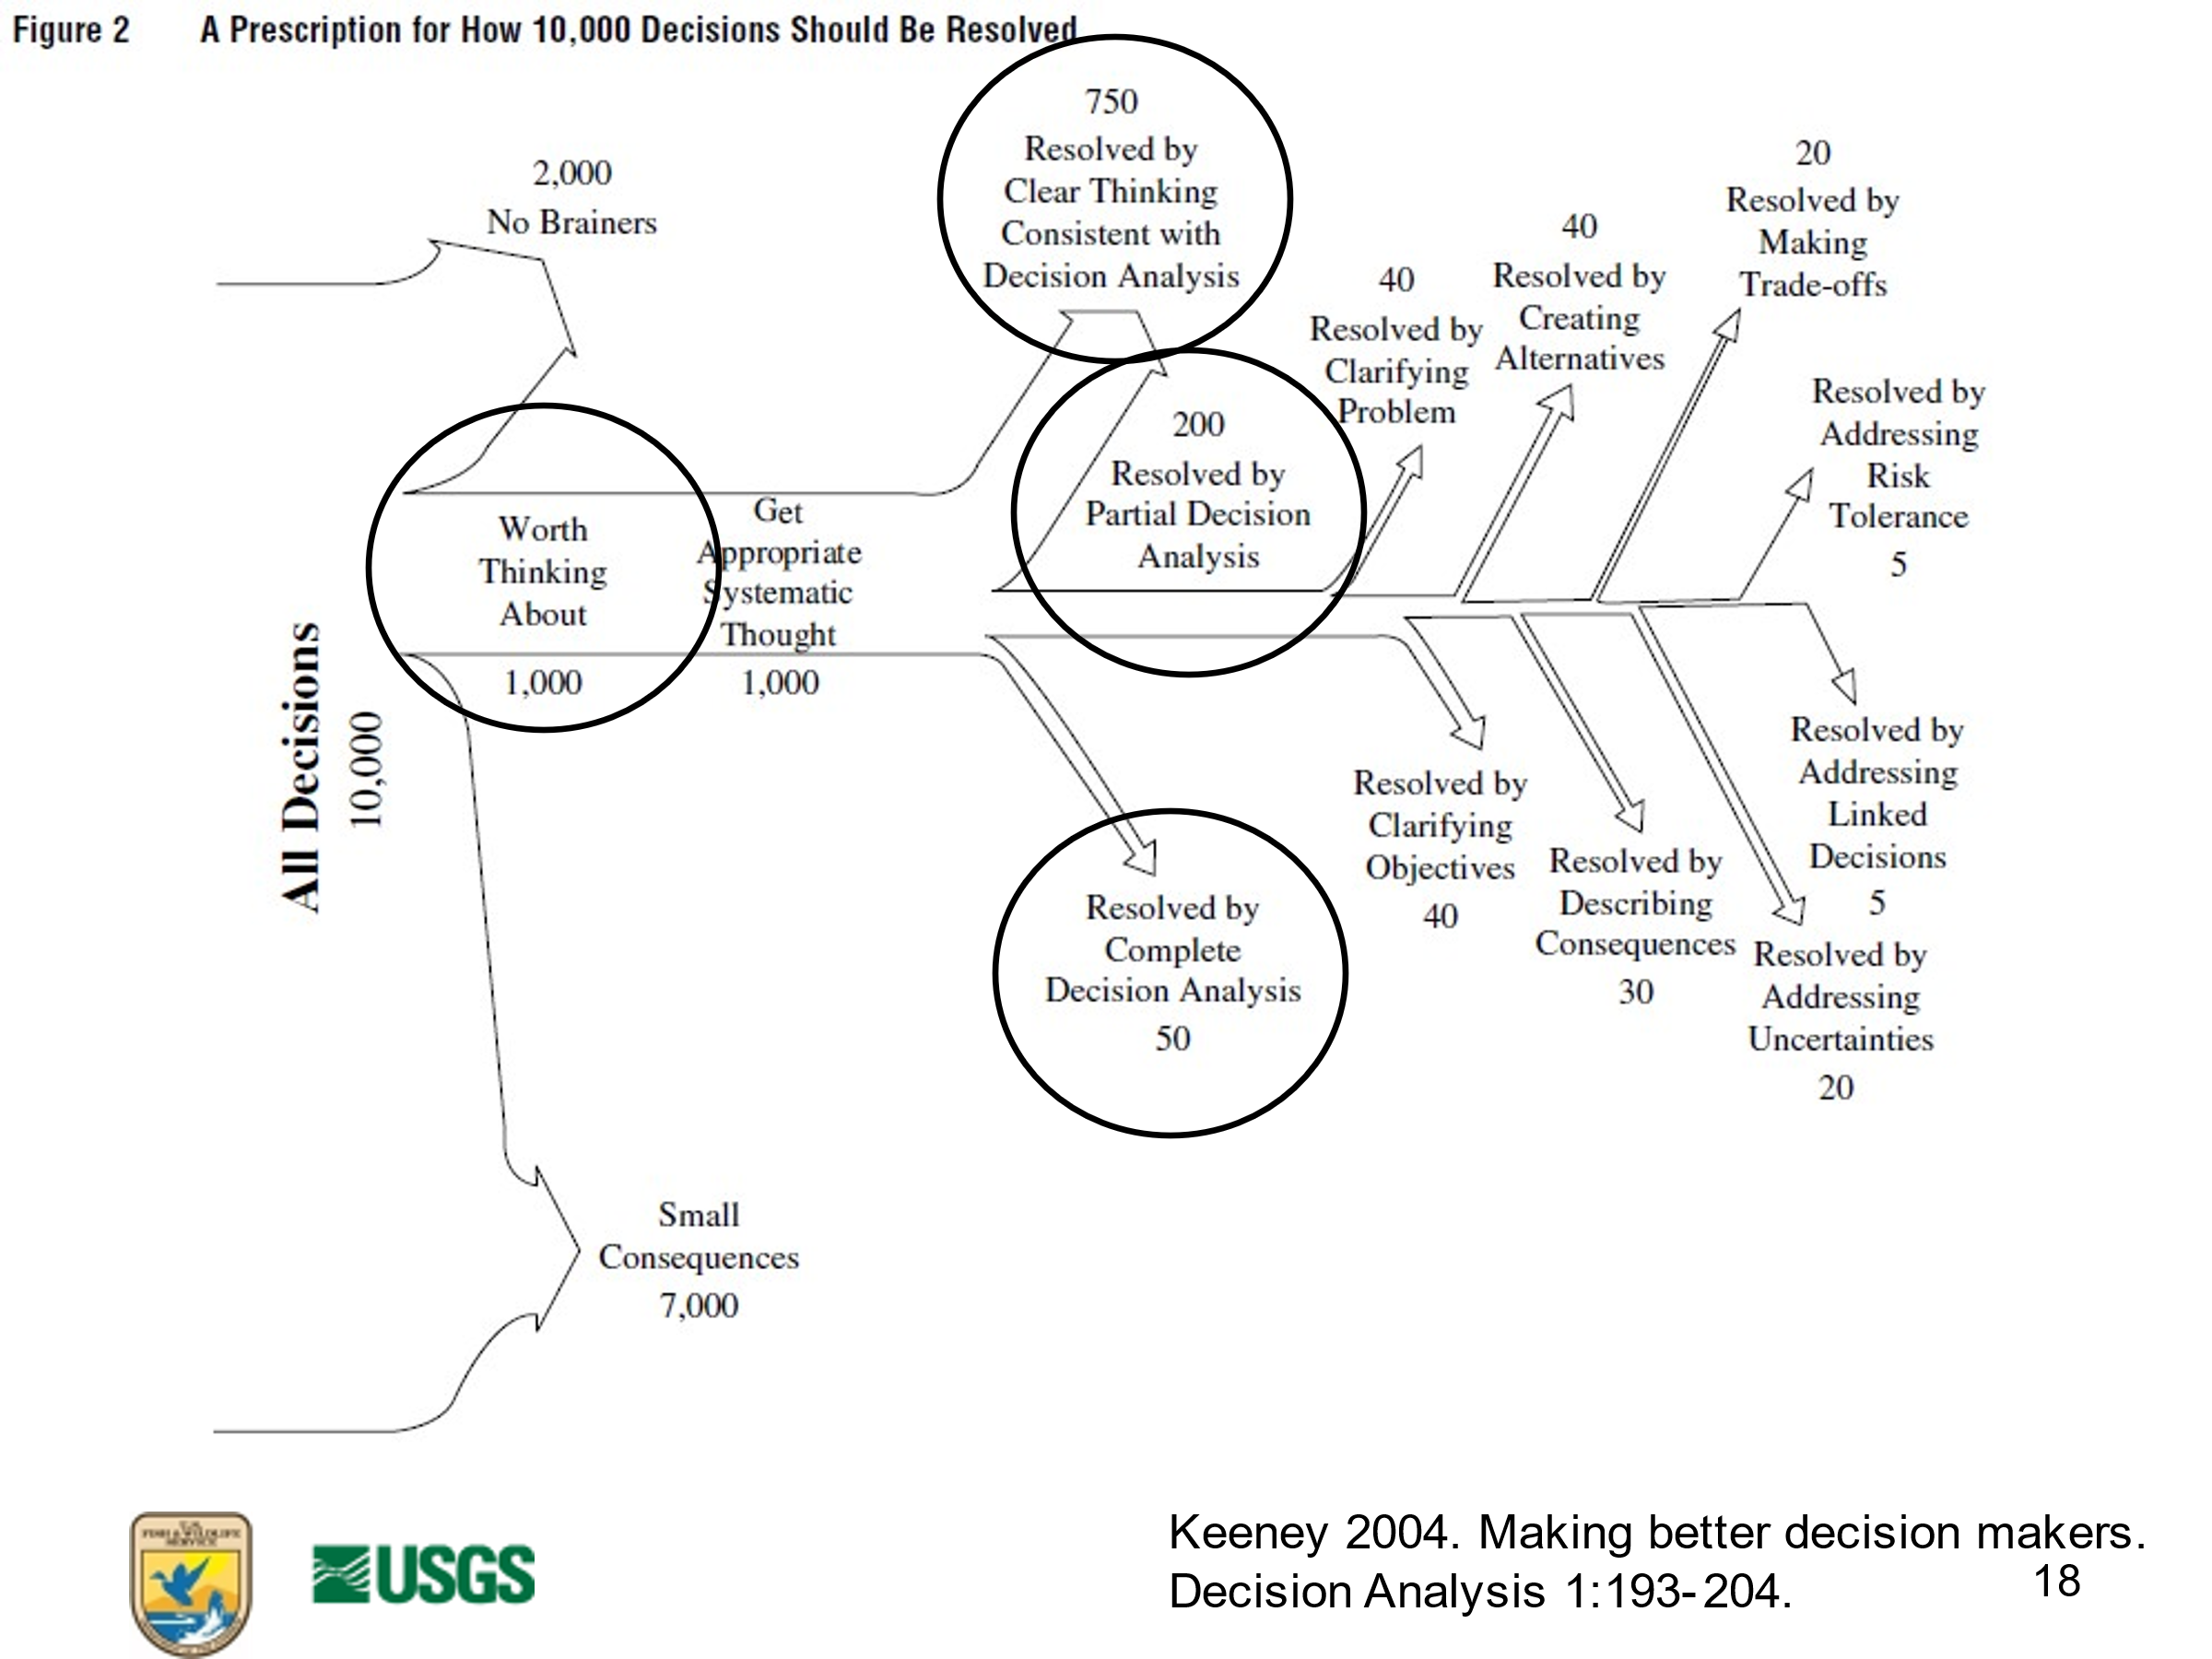

***How much analysis is needed? (How far along Keeney’s tree diagram do I need to go?)***

* Rarely (maybe 50 out of 10,000 or 0.5%) do decisions require the complete analysis to solve
* Structure and analyze the problem only as much as is needed to reach a good decision
* Hard to recognize at the beginning how much analysis is needed

**Prototyping**

* Prototyping the problem is useful for determining the necessary amount of complexity
* Engineers do not start by building a complex machine. They start with a prototype
* A prototype is amenable to testing and ‘trial and error’
* Low effort to make the prototype, thus less resistance to change if warranted
* Application of prototyping to structuring decisions
* Sketch the decision structure in low complexity, low resolution
* Add complexity as needed to analyze the prototype
* Gain insight from the prototype analysis regarding impediments
* Revise prototype as needed and reanalyze until a decision is reached

**When is Structured Decision Making most appropriate?**

* SDM is most appropriate for clearly defined decision problems with clear objectives, which might be competing, but not in dispute or obscured; and for state of the knowledge, which might be uncertain but not in dispute.
* In some circumstances where objectives or science are in dispute, by engaging in a facilitated structured decision process decision makers, stakeholders, and experts can move the problem into the space where consensus‐driven, cooperative decision making is possible.

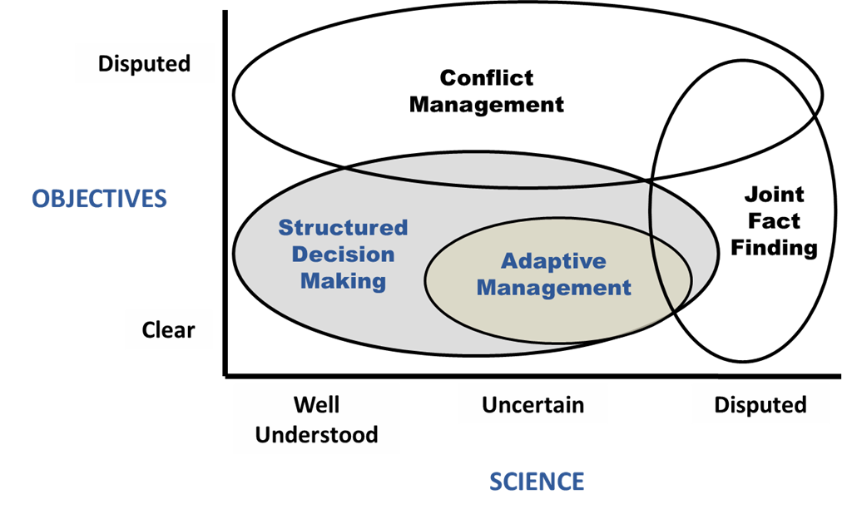

(Runge, M.C., Grand, J. B., & Michell, M. S. (2013). Structured decision making. In P. R. Krausman & J. W. Cain (Eds.), Wildlife management and conservation: Contemporary principles and practices (pp. 51–72). Johns Hopkins University Press).

***Benefits of SDM***

* Decision processes that are
* Deliberative, thorough, robust to uncertainty (that is, more likely to achieve the objectives)
* Transparent, explicit, able to be documented, replicable (that is, more likely to be accepted byothers)

***SDM can be useful for these decisions***

* Routine, one decision maker
* 1 person at their desk, an hour
* Fine‐tuning an impoundment drawdown schedule
* Small‐scale, one decision maker or closely collaborating decision makers, few stakeholders 
* Field office, days to weeks
* Bull trout Section 7 workload allocation
* Medium‐scale, multiple collaborative decision makers, many stakeholders
* Regional problems, months of analysis
* R4/R5 coordinated monitoring of migratory birds
* Large‐scale, multiple collaborative decision makers, many stakeholders
* National scope, years
* Waterfowl harvest regulations, Major listing decisions

**REFERENCES**

Howard RA. 1988. Decision analysis: practice and promise. Management Science. 34(6): 679‐695.

Howard RA, Abbas AE. 2015. Foundations of Decision Analysis. Prentice Hall.

Keeney RL. 1982. Decision analysis: An overview. Operations Research 30(5): 803‐838.

Keeney RL. 2004. Making better decision makers. Decision Analysis 1:193‐204.

Pielke, RA, Jr. 2007. The Honest Broker: Making Sense of Science in Policy and Politics. Cambridge

University Press.

Runge MC, Grand JB, Mitchell MS. 2013. Structured decision making. Pages 51‐72 *in* Krausman PR, Cain

JW III, eds. Wildlife Management and Conservation: Contemporary Principles and Practices. Johns Hopkins University Press, Baltimore, Maryland.

**MODULE DEVELOPED BY:**

David R. Smith, *USGS Leetown Science Center*

Jennifer A. Szymanski, *USFWS Midwest Region*

Michael C. Runge, *USGS Patuxent Wildlife Research Center*

Jean Fitts Cochrane, *Consultant (USFWS retired)*

Sarah J. Converse, *USGS Washington Cooperative Fish and Wildlife Research Unit, University of Washington*

Suggested Citation for this Module:

Smith DR, Szymanski JA, Runge MC, Cochrane JF, Converse SJ . 2016. Normative decision making.

Module 2 *in* Runge MC, Romito AM, Breese G, Cochrane JF, Converse SJ, Eaton MJ, Larson MA, Lyons JE, Smith DR,Isham AF. Introduction to Structured Decision Making, 2016 edition. U.S. Fish and Wildlife Service,National Conservation Training Center, Shepherdstown, West Virginia, USA.